AI ASSISTED CODING LAB
ASSIGNMENT 10.2
ENROLLMENT NO :2503A51L08
BATCH NO: 19
NAME: BHUKYA RAJESH

TASK1
TASK1 DESCRIPTION:-AI-Assisted Code Review (Basic Errors)
- Write python program as shown below.
- Use an AI assistant to review and suggest corrections
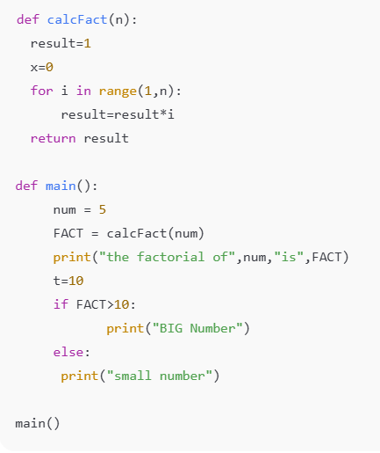

CODE:-
Error Code:-
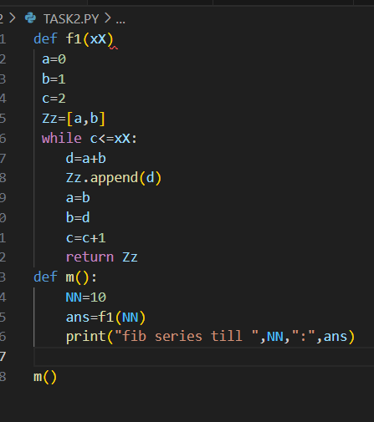
OUTPUT:-
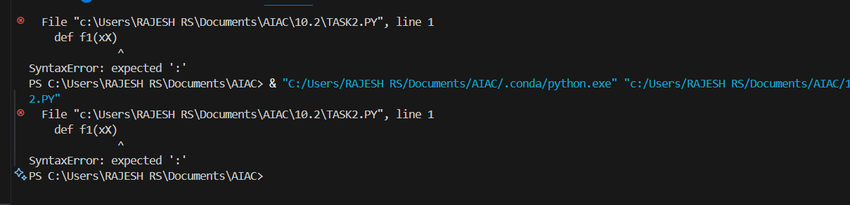
Correct Code:-
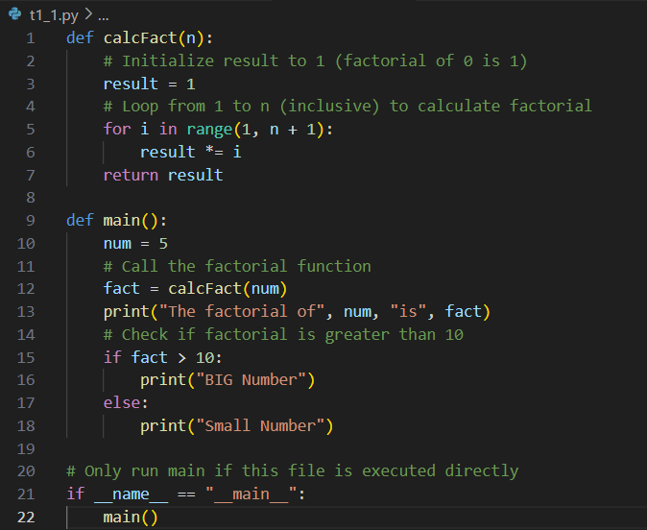
OUTPUT:-
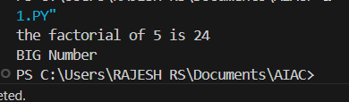

OBSERVATION:-
In this task, I wrote a Python program that contained basic syntax or logical errors. I then used an AI assistant to review the code and suggest corrections. The AI successfully identified the errors and provided a corrected version of the code, along with explanations. This helped me understand common mistakes and how to fix them efficiently.

TASK2
TASK2 DESCRIPTION:- Automatic Inline Comments
- Write the Python code for Fibonacci as shown below and execute.
- Ask AI to improve variable names, add comments, and apply PEP8 formatting (cleaned up).
- Students evaluate which suggestions improve readability most.
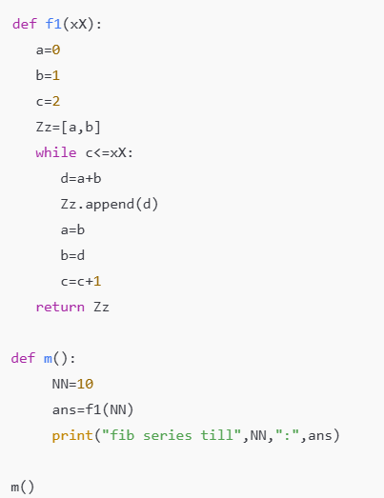
CODE:-
Given Code:-
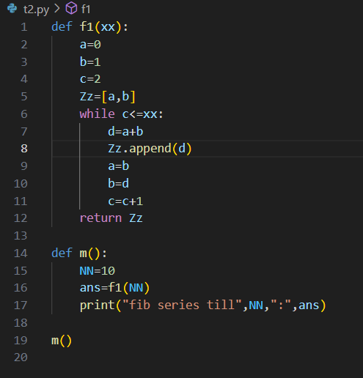
Output:-
AI Generated Code:-
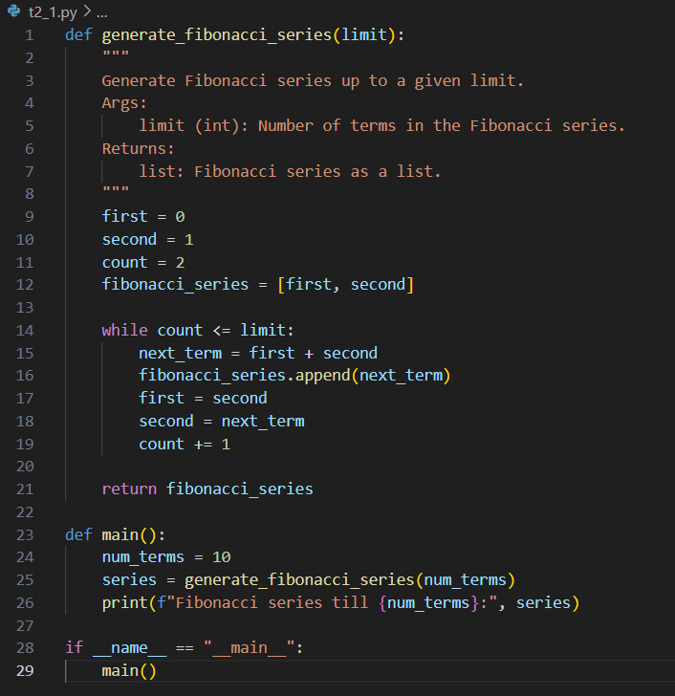
Output:-
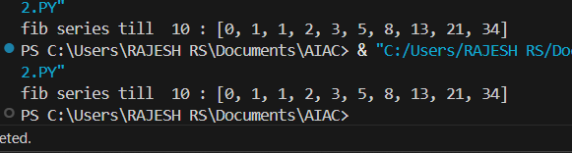

OBSERVATION:-

For this task, I implemented a Python program to generate Fibonacci numbers. After writing the initial code, I asked the AI assistant to improve variable names, add comments, and format the code according to PEP8 guidelines. The AI-generated version was clearer and easier to understand, especially for beginners.
TASK3
TASK3 DESCRIPTION:-
- Write a Python script with 3–4 functions (e.g., calculator: add, subtract, multiply, divide).
- Incorporate manual docstring in code with NumPy Style
- Use AI assistance to generate a module-level docstring + individual function docstrings.
- Compare the AI-generated docstring with your manually written one

PROMPT 1:
Write a Python script with 3–4 functions (e.g., calculator: add, subtract, multiply, divide)
CODE GENERATED :
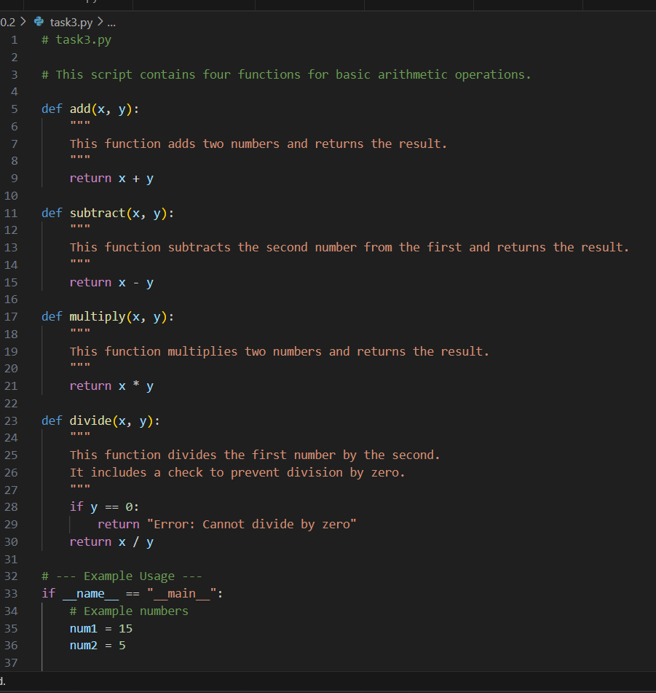
OUTPUT:
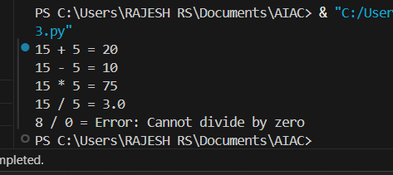
PROMOT 2:
Incorporate manual docstring in code with NumPy Style
CODE GENERATED:
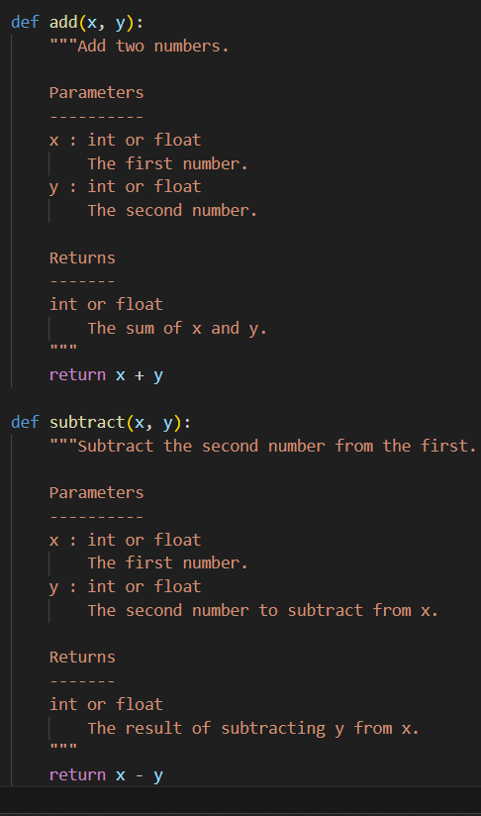
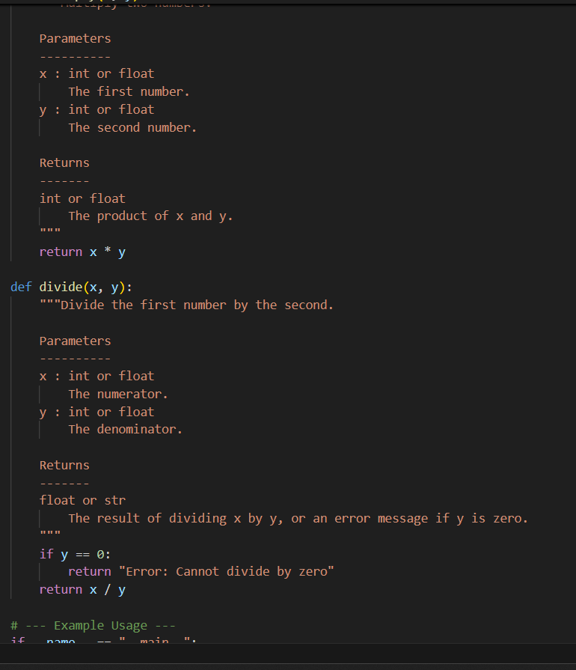

PROMPT 3:
• Generate a module-level docstring + individual function docstrings.
CODE GENERATED :
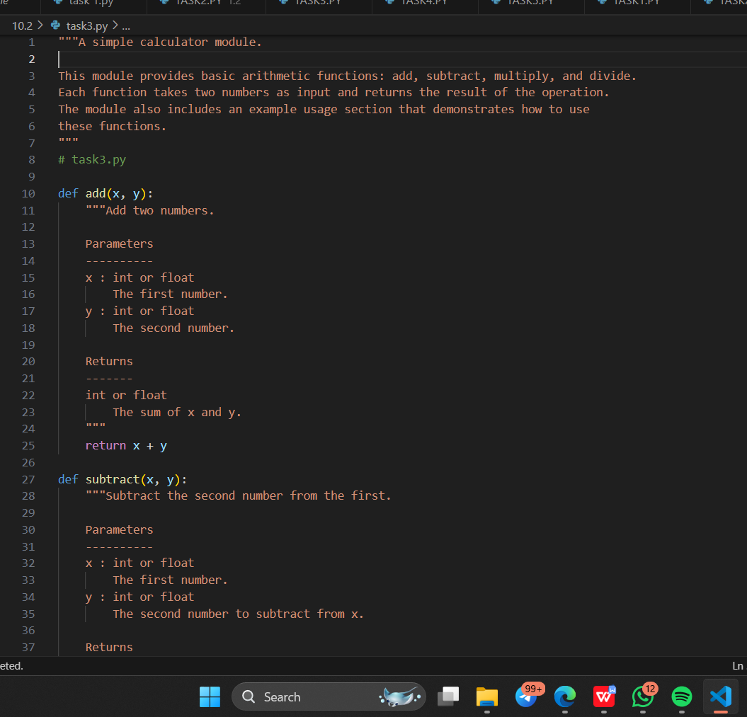

OBSERVATION:-
In this task, I created a Python script containing multiple functions such as add, subtract, multiply, and divide. I manually wrote docstrings using the NumPy style format to describe each function’s purpose and parameters. Then, I asked the AI to generate its own module-level and function-level docstrings.

